***Gaming Chair***

***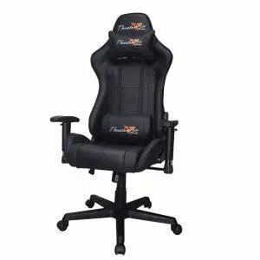****Gaming chairs are specialized seating options designed to enhance comfort and performance during long gaming sessions. They typically feature ergonomic designs that provide excellent support for the back, neck, and arms, which can help prevent discomfort and improve posture. Common features include adjustable armrests, seat height, and reclining angles, with many models also offering lumbar and neck pillows for additional support. Gaming chairs are made from high-quality materials such as PU leather, fabric, or mesh, with a sturdy frame to ensure durability. Pricing varies widely, with budget options starting at around $100 to $200, offering basic comfort and support. Mid-range chairs generally cost between $200 and $400, offering better ergonomics and more durable materials. High-end gaming chairs, priced above $400, often feature advanced ergonomics, premium build quality, and extra features such as built-in speakers or massage functions for a luxury gaming experience.*